PROJECT REPORT
Summer Training — Power BI
Student Exam Results Analyzer

Project Title | Student Exam Results Analyzer
Student Name | Nana Sirri CHE Lovette Claire
Roll Number | 2419712
Course & Batch | B.Tech Blockchain — 2024/2028
Department | CCE
Institute | CGC University, Jhanjeri
Training Period | 08/06/2026 to 06/07/2026 [One Month]
Submission Date | 03/07/2026
Guided By | Dr ASHIMA

1. Declaration

I hereby declare that the project report entitled "Student Exam Results Analyzer" submitted in partial fulfillment of the Summer Training Programme is an original piece of work carried out by me. The data used in this report has been collected from publicly available sources. The dashboards, visuals shown in this report have been independently created by me in Microsoft Power BI Desktop.

I further confirm that this report or any part of it has not been submitted previously for any academic award.

Signature: ____NANA_SIRRI_CHE_LOVETTE_CLAIRE___
Name: Nana Sirri CHE Lovette Claire
Date: 02/07/2026

2. Abstract

Project Summary
Problem Statement: Educational institutions often struggle to identify which factors most influence student exam performance, making it hard to target interventions effectively. This dashboard addresses that gap by helping administrators and educators understand how demographic and preparatory factors affect Math, Reading, and Writing scores. It enables data-driven decisions around resource allocation, such as promoting test preparation programs.
Dataset: The analysis uses the "Students Exam Scores" dataset, containing student-level records with three performance measures (Math, Reading, Writing scores) alongside five categorical fields: gender, race/ethnicity, parental level of education, lunch type, and test preparation course status. The dataset spans roughly 1,000 student records, structured as a single flat table before modeling.
Power BI Features: Power Query was used to clean and shape the raw data, while a star schema data model (fact table + five dimension tables) was built for optimized performance. DAX measures calculated aggregated scores, and visuals included KPI cards, waterfall charts, donut/pie charts, and line/bar charts across gender, ethnicity, and education levels.
Students completing the test preparation course consistently outperformed those who didn't, regardless of parental education level, making it the most actionable lever for improving scores school-wide.

3. Introduction

3.1 Background
This project belongs to the education analytics domain, which focuses on collecting, analyzing, and interpreting student performance data to improve educational outcomes. Schools, colleges, and education authorities generate large volumes of data related to student exam scores, attendance, demographics, and learning progress. By analyzing this information, educators can identify performance trends, measure academic achievement, and develop strategies to enhance teaching and learning.These insights help stakeholders understand the factors that influence student achievement.

Why Data Visualization Matters in Education
Data visualization transforms complex educational data into clear, interactive charts and graphs that are easy to understand. Instead of reviewing large tables of exam results, users can quickly identify:
- Overall trends in student performance.
- Achievement gaps between different demographic groups.
- The impact of parental education and test preparation on academic results.
- Differences in performance across subjects such as math, reading, and writing.
- Areas where additional academic support or interventions may be required.
Visualizations improve communication, speed up analysis, and support evidence-based decision-making.

How Organizations Use Dashboards to Make Decisions
Educational institutions and organizations use dashboards to monitor performance and guide strategic planning. Typical uses include:
- Monitoring academic performance: Tracking student scores across different subjects to measure learning outcomes.
- Identifying at-risk students: Detecting groups or individuals who may require additional academic support.
- Evaluating educational programs: Assessing the effectiveness of initiatives such as test preparation courses or learning interventions.
- Promoting equity: Comparing performance across demographic groups to identify achievement gaps and develop inclusive policies.
- Resource allocation: Directing teachers, funding, and support programs to areas with the greatest need.
- Reporting to stakeholders: Providing school administrators, teachers, parents, and education authorities with clear summaries of student performance and institutional progress.

3.2 Problem Statement
- Educational institutions often struggle to identify which factors most influence student exam performance, making it hard to target interventions effectively. This dashboard addresses that gap by helping administrators and educators understand how demographic and preparatory factors affect Math, Reading, and Writing scores. It enables data-driven decisions around resource allocation, such as promoting test preparation programs.

3.3 Objectives
- Connect to and clean the raw datasets using Power Query.
- Design a star schema data model with proper relationships.
- Create meaningful DAX measures (minimum 3 custom measures).
- Build an interactive dashboard with at least 5 different visual types.
- Enable drill-through or cross-filtering for deeper analysis.
- Publish the final report to Power BI Service.

4. Dataset Description

4.1 Data Source

Source Name | Kaggle
Dataset Name | StudentsPerformance.csv
File Format | Excel
Number of Rows | 1000
Number of Columns | 8
Time Period Covered | 3-5 days
Download Link | https://www.kaggle.com/datasets/spscientist/students-performance-in-exams?datasetId=74977

4.2 Key Fields / Columns
List and describe the important columns used in your analysis:

Column Name | Data Type | Description / Role in Analysis
Gender | Text | To compare performance between male and female students
Race/Ethnicity | Text | To analyze score distribution across different groups
Test Preparation Course | Text | To compare scores before and after preparation
Maths Score | Integer | Measures students performance in mathematics.
Reading Score | Integer | Measures students performance in reading.
Parental Level Of Education | Text | Measures impact of parents education on student performance
Writing Score | Integer | Measures students performance in writing.
Lunch | Text | To study the relationship between nutrition and academic performance

4.3 Data Quality Issues & Cleaning Steps
Describe what problems you found in the raw data and how you fixed them in Power Query:
- Removed duplicate rows — found [X] duplicates using Remove Duplicates in Power Query.
- Handled null values — [Column Name] had [X] blanks; replaced with 'Unknown' / removed rows.
- Changed data types — Order Date was stored as Text; converted to Date type.
- Split columns — [e.g., Full Name split into First Name and Last Name].
- Filtered rows — removed [e.g., canceled orders / test rows].
- Data cleaning via Excel using [PROPER, TRIM].

5. Data Modelling

5.1 Schema Design
Describe the data model you built. State whether you used a Star Schema or Snowflake Schema. List the Fact table and Dimension tables:

Schema Type | Single Data Model
Fact Table | Student Exam Performance  contains numeric measures like maths,reading,writing scores.
Dimension Table 1 | Gender  Female, Male.
Dimension Table 2 | Parental Level Of Education  High School, Bachelor’s, Master’s, Associate Degree.
Dimension Table 3 | Race/Ethnicity  Group A, B, C, D, E.
Dimension Table 4 | Test Preparation Course -- Completed, None.
Dimension Table 5 | Lunch — Standard, Free/Reduced.
Relationships | No relationships required since all data is stored in one table.

5.2 Data Model

Dataset Structure

Source: Student Exam Performance Dataset

Total Records: 1000 rows

Total Columns: 8 columns

Fields Used

Gender

Race/Ethnicity

Parental Level of Education

Lunch

Test Preparation Course

Math Score

Reading Score

Writing Score

Data Model Type

Single Table Model

No relationships required since all data is stored in one table

Purpose

Used to analyze student performance across demographics and exam scores.

Dataset Structure

Source: Student Exam Performance Dataset

Total Records: 1000 rows

Total Columns: 8 columns

Fields Used

Gender

Race/Ethnicity

Parental Level of Education

Lunch

Test Preparation Course

Math Score

Reading Score

Writing Score

Data Model Type

Single Table Model

No relationships required since all data is stored in one table

Purpose

Used to analyze student performance across demographics and exam scores.

6. Dashboard & Visuals

6.1 Page 1 — Summary / Overview
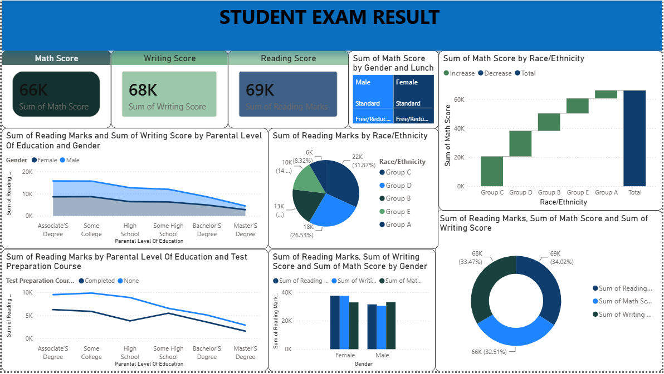

6.2 Page 2
Visuals And Key Insight From The Dashboard

Visuals used on this page:
- KPI Cards — Maths, Reading and Writing Scores
- Pie Chart
- Sum of reading marks by race/ethnicity
- Sum of all scores
- Bar Chart — Sum of reading and maths marks by gender
- Waterfall — Sum of maths score by race/ethnicity
- Line Chart — Sum of reading marks by parental level of education and test preparation course.

Key insight from this page
At a glance, this dashboard shows aggregate exam performance broken down by gender, race/ethnicity, parental education level and test preparation status. The visuals highlight patterns like Group A leading in math scores and test-prep completion correlating with higher reading scores, making it easy to spot which demographic factors influence results.

6.3 Drill-through Page
Drill-through filter used: Race/Ethnicity
What this page shows: Displays detailed student-level exam records for the selected Race/Ethnicity group. When a user right-clicks a race/ethnicity category (e.g., Group A, Group B, Group C) on the main dashboard and selects Drill Through, they are taken to a page showing detailed information such as:
Individual Math, Reading, and Writing scores
Gender
Lunch type (Standard/Free-Reduced)
Test preparation course status
Parental level of education
Overall performance for the selected group
Purpose: This drill-through page enables users to investigate the detailed records behind the summary visuals, compare individual student performance within a selected race/ethnicity group, and identify patterns or factors influencing academic achievement.

7. Key Findings & Insights

- Female students performed slightly better overall
- The gender comparison chart shows female students scored slightly higher than male students in reading and writing.
- Math performance appears close, but females still show stronger overall academic consistency.
- Reading and writing scores are strongly correlated
- Students with high reading marks also tend to have high writing scores.
- This suggests strong literacy skills usually improve both areas together.
- Test preparation course improves performance
- Students who completed the test preparation course scored noticeably higher in reading.
- This indicates preparation has a positive impact on academic results.
- Parental education influences student scores
- Students whose parents have higher education levels (Bachelor’s/Master’s degree) generally scored better.
- Students from lower parental education backgrounds showed relatively lower average marks.
- Performance varies across race/ethnicity groups
- The race/ethnicity visuals show score differences among groups.
- Some groups consistently perform better in math, reading, and writing, indicating demographic patterns in academic performance.

8. Learnings & Challenges

8.1 Skills Learned
- Connecting to and transforming raw CSV/Excel data using Power Query.
- Building a proper star schema with one-to-many relationships.
- Writing DAX measures using SUM, CALCULATE, FILTER, DIVIDE, DATEADD.
- Designing user-friendly dashboards with slicers, drill-through, and cross-filtering.
- Data Cleaning via Excel using PROPER,TRIM.

8.2 Challenges Faced
- Messy or inconsistent categorical data (e.g., "Group A/B/C/D/E" labels, inconsistent parental education naming)
- Getting DAX measures and relationships correct (e.g., Sum of Math Score by Gender and Lunch)

9. Conclusion

This project successfully addressed the original problem statement by analyzing student exam performance and identifying the key factors influencing academic results. The dashboard provided meaningful insights into how gender, parental education, lunch type, race/ethnicity, and test preparation affect student scores in math, reading, and writing. It adds value for teachers, school administrators, parents, and education analysts by helping them make data-driven decisions to improve student performance and provide targeted support where needed. The interactive visualizations make complex data easier to understand and compare. If given more time, I would improve this project by adding predictive analysis, advanced KPIs, and more detailed student-level performance tracking to provide deeper insights and support better academic planning.

10. References

- Microsoft Power BI Documentation — https://docs.microsoft.com/en-us/power-bi/
- Dataset's Source — https://www.kaggle.com/datasets/spscientist/students-performance-in-exams?datasetId=74977
- DAX Reference Guide — https://dax.guide/
- Power Query M Reference — https://docs.microsoft.com/en-us/powerquery-m/

END OF REPORT

